Communicating with Students

The Navigate platform provides both email and text messaging for faculty and staff to communicate with students, either individually or in mass. Communicating with students through the platform creates records of those communication which can be accessible by other staff or faculty on your campus. In addition, it allows for a quick and easy way to communicate with more than one student at once.

Any faculty or staff member will only be able to view communications in which they have the proper permissions. Permissions allow users to either view only their own communications with students, or to view all communications with students. If you are unsure who can view your communications, email Navigatehelp@wsutech.edu for permission inquiry.

Email
Within an email, you can include the following information:
- Subject: The subject line for your email message.
- Message: The body of your email message. There is no character limit for the message.
- Add Attachment: Upload attachments to the email message.
- Send Additional E-Mail Notifications To: Allows you to include additional students or staff you also want the email sent to.

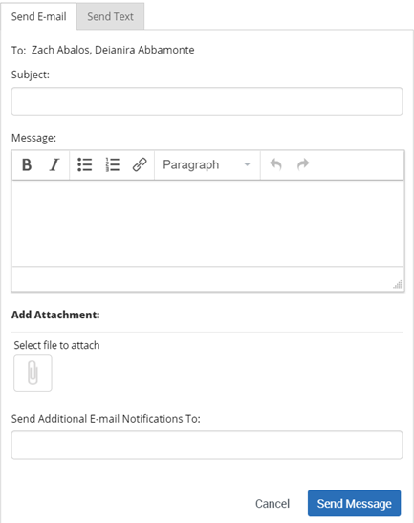

Text
Within a Text, you can only include a Message. You are restricted to 160 characters

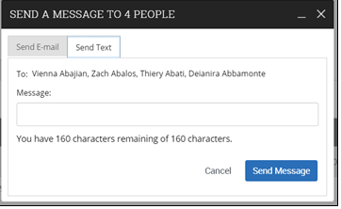
Important Note: Sending an email or text message to more than one student will blind copy all students. In other words, the student will not know that the message was sent to more than one student. For both email and text, it will look like the message was only sent to them.
How do I send the emails or texts?
You can send emails or texts to one or more students from your staff homepage, the student profile, or the advanced search. Most “Actions” menus throughout the platform allow for sending emails or texts. See below for screenshots of each of these locations.
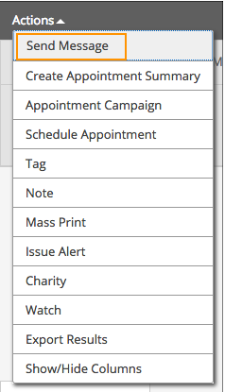

Send message action on the Staff Home page
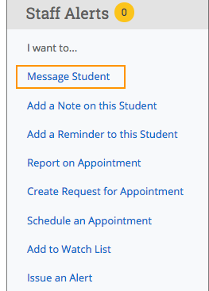

Message Student link on Student profile.
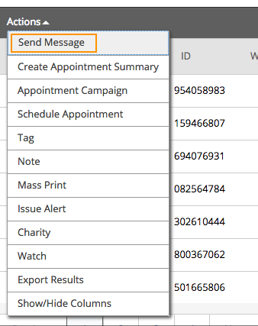

REMEMBER

Please make sure you keep communication on text to a minimum and use email for longer more detailed communication. Please keep the communication professional and use proper spellings (no Emoji’s).

Frequently Asked Questions
When I send an email to text to multiple students at once, will they know that it was a mass message? Can they see the names, emails, or phone numbers of the other students? No. The email and text will look like it was only sent to that one student. The student will not see other student names or emails.
If the student responds to the email or text message, will it respond to all other students that were sent that same message? No. Even though you sent the message to more than one student at once from the platform, the message that is delivered is only sent to that one student. That means that the student can respond, and the reply will only go to the initiator, not any of the other students.
What happens if you try to text a student from the platform but there is no cell phone number available for the student? The text message will be sent to the student’s email address instead. Students also can input or change their cell phone number when scheduling an appointment in the platform.
What email address does the email come from? If your institution has configured email capture, then the platform will send and receive messages from a special subdomain. For example, an advisor sends an email to students through the Navigate platform. The email’s From field will display the subdomain (advisor@support.whitehurst.edu), not the advisor’s actual email (advisor@whitehurst.edu). If a student responds to the message, the message will display from the student’s subdomain (student@support.whitehurst.edu), not the student’s actual email (student@whitehurst.edu). All messages will still be captured in both the Navigate platform and the institution’s email client. To learn more about configuring email capture, please read this article.
What phone number does the text come from? Automated text messages (i.e., appointment reminders or cancellation notices) and texts sent to more than 50 students will be sent from the platform’s shortcode, “915-52.” If your institution configures dedicated Navigate phone numbers for all staff members, then the text message will send from that dedicated phone number. To learn more about configuring text messaging, please read this article.
Where are the messages sent to the Navigate platform saved? If your institution has configured email capture, then the messages will be saved in both Navigate and your institution’s email client. To learn more about configuring email capture, please read this article.
Can students opt out of text messaging? Yes, they can reply STOP to any text received from WSU Tech and it will change their setting in the platform to no longer send them text messages from the WSU Tech. Text messages users attempt to send to this student will be routed to their email instead. The STOP opt-out only applies to text messages received.
Will staff members receive any texts or emails on their personal cell phone? No, communication will go to the staff WSU Tech email or the staff Navigate home page (left top envelope icon).
Info-Help Navigate

